Principles of Interpretation
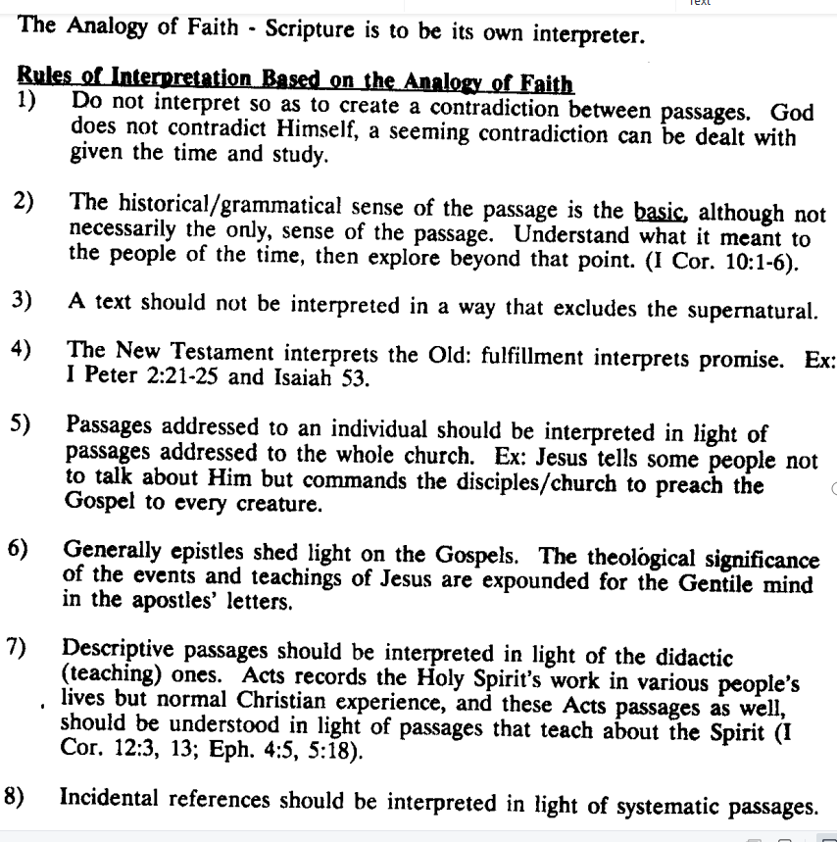
Approaching the Task (the Inductive Bible Study Method)
- Observation – What do we see/observe in the text? Observe objectively what the text actually says and all the details that are in the text.

- Interpretation – What does the text mean? Ascertain the meaning of what is in the text. This often involves using various resources.

- Application – How does or should the text affect me and real life? What should I do in response to the text?

